Citation directions
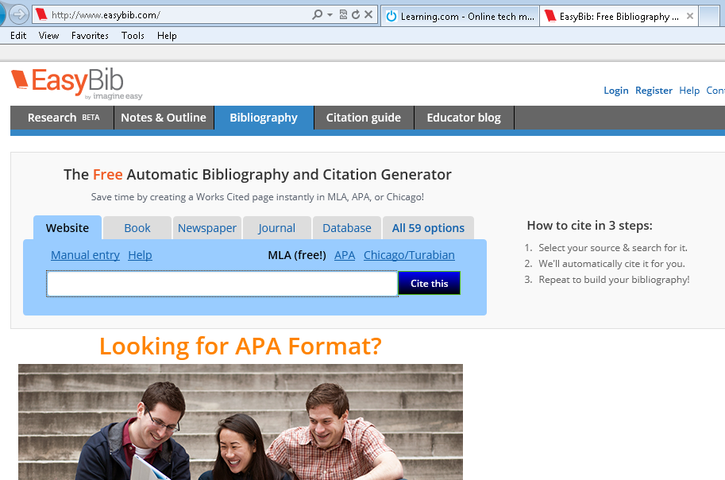
- Go to Internet explorer and type in easybib.com in the URL bar, at the top of your screen.
- Easy bib will open , click on Manual entry

- Open your word document you created yesterday, this will have your health link.
- Hold down control button on keyboard ( left bottom key) and click the mouse
http://kidshealth.org/kid/cancer_center/treatment/radiation.html
- Once at your link, you must look for the following items to complete your citation. You must look carefully
Article title
Website title
Publisher or Sponsor - It is often found on the bottom
of the web page, but not always.
URL – the link
Date it was published - look for a copyright sign
or a specific date

Date accessed - the date you actually read the article.
- Now click on create citation.
- Copy the created citation and paste the citation on to the
Word document you made yesterday in health.
Repeat steps 1- 7 for your 2nd link.

- Save this document, you should have 2 citations done by the end of the period today.
- Research must be completed, on your own time ,the project with the citation handed in on MONDAY March 17th in Mrs. Wasnick’s room .

